**Two Tank Interacting System**

GROUP NO: 5

NAMES:

Sayan Dasgoswami 21EE62R11

Sai Joshitha Annareddy 21EE62R10

Pooja Singh Patle 21EE62R02

OBJECTIVE:

Control of Two Tank Interacting System using

1. State feedback controller design.

2. Observer based controller design.

3. Linear Quadratic Regulator (LQR) based controller design.

ABSTRACT:

Liquid tanks which are generally used in industrial facilities have strategic importance because of significance of storage which are highly important for human life. In the process of industrial applications, frequently it is essential to may be store up in tanks and transferred to other tanks as per requirement. It is often necessary to keep the liquid at a certain height or within a certain range. Liquid level control is used in for different industrial applications, like in food processing, water purification systems, filtration, pharmaceutical industries, etc. The state space method of system design is a generalized time domain method for modelling, analysing and designing a wide range of control systems. The two-tank interacting system is a non-linear system, hence the project deals with linearisation of a non-linear model and to develop controllers to control the linear as well as the actual non-linear model.

**STATE FEEDBACK CONTROLLER DESIGN**

A. LINEAR MODEL:

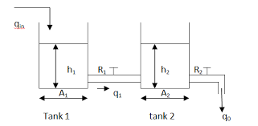

**Figure 1**: Two interacting tank system

i) For tank-1:

Hence,

Time constant for tank-1 = 𝜏1= R1A1

ii) For tank-2:

Hence,

Time constant for tank-2 = 𝜏2= R2A2

Where:

1. h1 (m) = The height of the liquid level in tank-1

2.h2 (m) = The height of the liquid level in tank-2

3. qin­ (m3 /sec) = Volumetric flow into tank-1

4. q1 (m3 /sec) = Volumetric flow rate from tank-1

5. q0 (m3 /sec) = Volumetric flow rate from tank-2

6. A1 (m2) = Cross sectional area of tank-1

7. A2 (m2) = Cross sectional area of tank-2

8. R1, R2= Resistance parameter (valve) in flow line

1. SPECIFICATION TABLE:

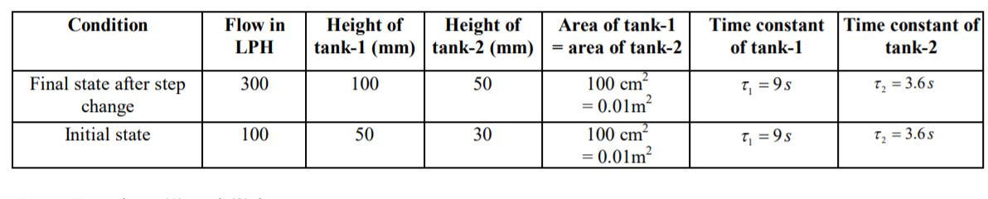

2. CONTROLLER DESIGN:

a) Model Specifications:

1. Damping ratio (**ζ**) = 1.739

2. Natural Frequency (ωn) = 31.62 rad/sec

b) Design algorithm and steps:

**Step 1:** State space representation of the system

We have two states h1 and h2. Let h1 = x1 and h2 = x2

Hence, the state space equation is given as:

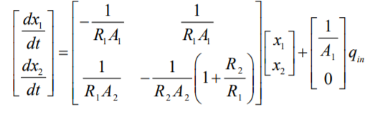

The output equation is given as:

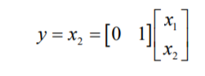

**Step 2:** Calculation of values of elements of A, B matrices

R1 = 𝜏1/A1 = 900 s/m2

R2= 𝜏2/A2 = 360 s/m2

Therefore,

A = , B =

Where:

A = State matrix (2✕2)

B = Input matrix (2✕1)

**Step 3:** System Dynamics

**ẋ = Ax +Bu**

where:

x = state vector (2✕1)

u = control signal (scalar)

A = State matrix (2✕2)

B = Input matrix (2✕1)

As we are designing the controller based on State feedback control

Hence,

u = -Kx

where:

K = State feedback gain matrix (1✕2) = [k1 k2]

**Step 4:** Check controllability condition for given system:

Controllability Matrix = Mc = |B AB| = (2700 - 0) = 2700 ≠ 0

Hence Mc is a full rank matrix with rank = 2. So, the given system is controllable.

**Step 5:** Desired closed loop characteristic equation

s2 + (2**ζ**ωn)s +ωn2 = 0

s2 + 110s +1000 = 0

**Step 6:** The closed loop State matrix = A – BK

Hence, closed loop characteristic equation is given as |sI - A + BK | = 0

= 0

s2 + (0.498 + 100k1)s + (38.8k1 + 27k2 +0.013) = 0

By comparing the above equation with desired closed loop characteristic equation, we get

k1 = 1.09 and k2 = 87.12.

Therefore K = [1.09 87.12].

Value of K from Ackerman’s formula using MATLAB gives K = [1.09 87.12].

**Step 7: MATLAB Model and Simulation**

a) Simulink Model:

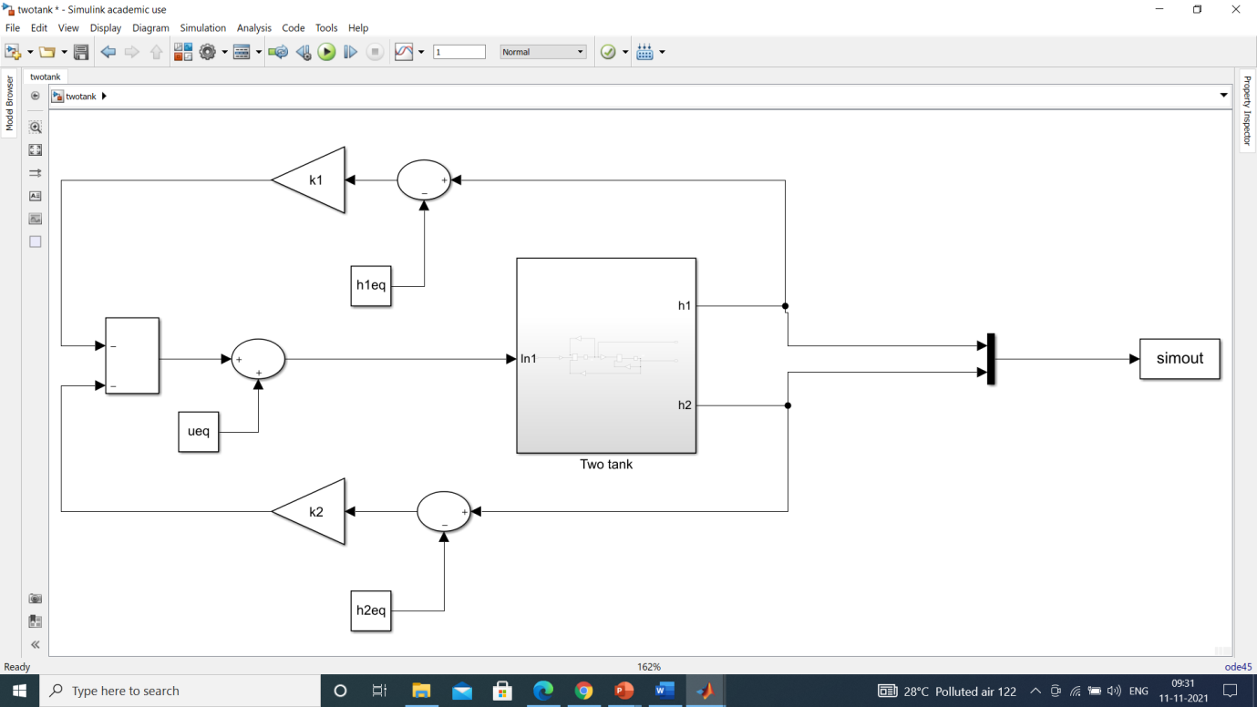

**Figure 2**: Simulink Model of Linear Two Tank interacting system with state feedback control.

b) Subsystem:

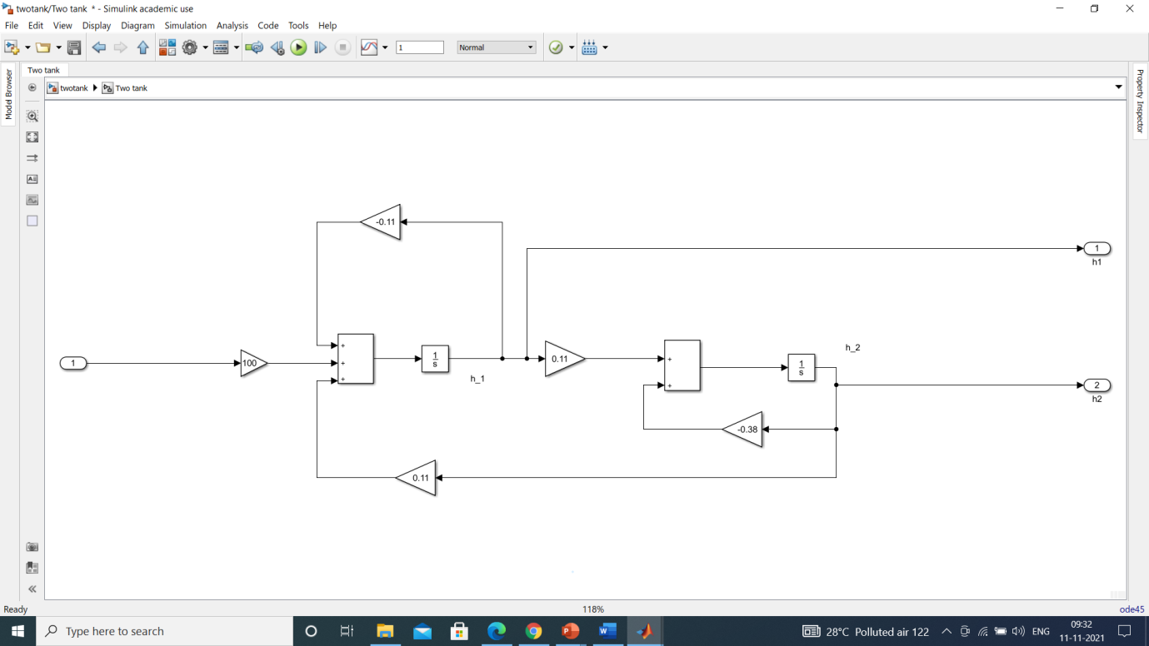

**Figure 3**: Simulink Model of Linear Two Tank interacting system

c) **MATLAB Code:**

clear all;clc

k1 = 1.09;k2 = 87.12;

h1_0=0;

h2_0=1;

h2eq=0;

h1eq = 0.38*h2eq/0.11;

ueq = (0.11*h1eq-0.11*h2eq)/100;

sim('twotank');

t = ans.simout.time();

y1 = ans.simout.data(:,1);

y2 = ans.simout.data(:,2);

subplot(211);plot(t,y2,'b','linewidth',1); xlabel('time');grid on

subplot(212);hold on;plot(t,y1,'b','linewidth',1); grid on

**d) Simulation Results(graph):**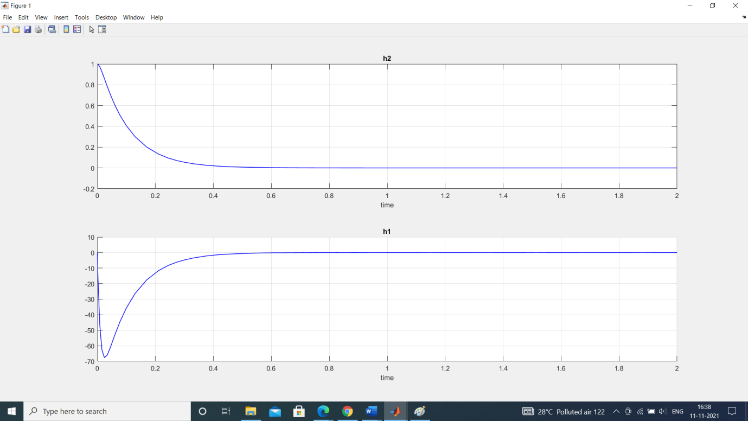

**Figure 4:** Response curve of closed-loop control system with initial condition [0 1].

**B. Performance of controller on Non-Linear Model:**



**Figure 5**: Two interacting tank system

Mathematical Modelling:

Where:

1. h1 (m) = The height of the liquid level in tank-1

2.h2 (m) = The height of the liquid level in tank-2

3. qin ­(m3 /sec) = Volumetric flow into tank-1

4. q1 (m3 /sec) = Volumetric flow rate from tank-1

5. q0(m3 /sec) = Volumetric flow rate from tank-2

6. A1 (m2) = Cross sectional area of tank-1

7. A2 (m2) = Cross sectional area of tank-2

8. R1, R2= Resistance parameter (valve) in flow line

9. ρ1 = Proportionality constant of Tank 1

10. ρ2 = Proportionality constant of Tank 2

11. ρ = 1 = specific gravity of water

The same value of State feedback gain matrix is used to check the performance of the controller on non-linear system

**1.** **Simulink Model:**

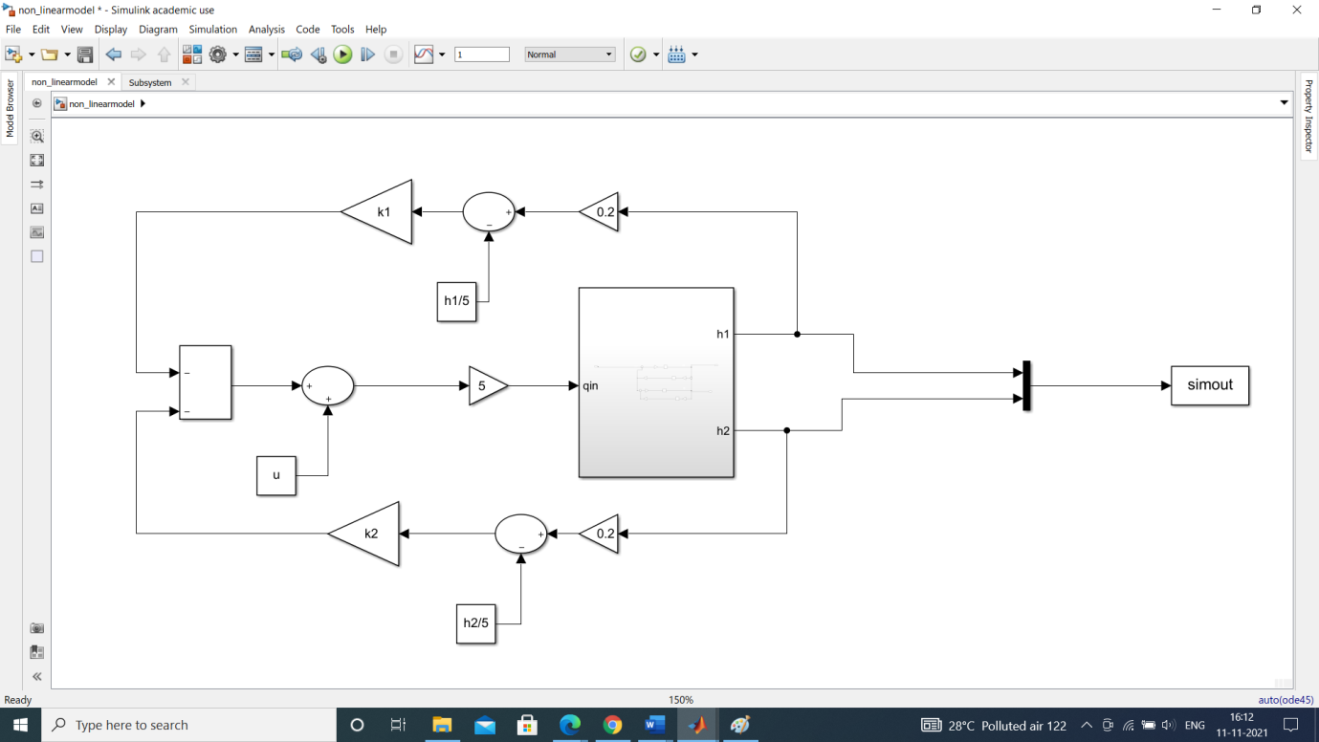

**Figure 6**: Simulink Model of Non-linear Two Tank interacting system with state feedback control.

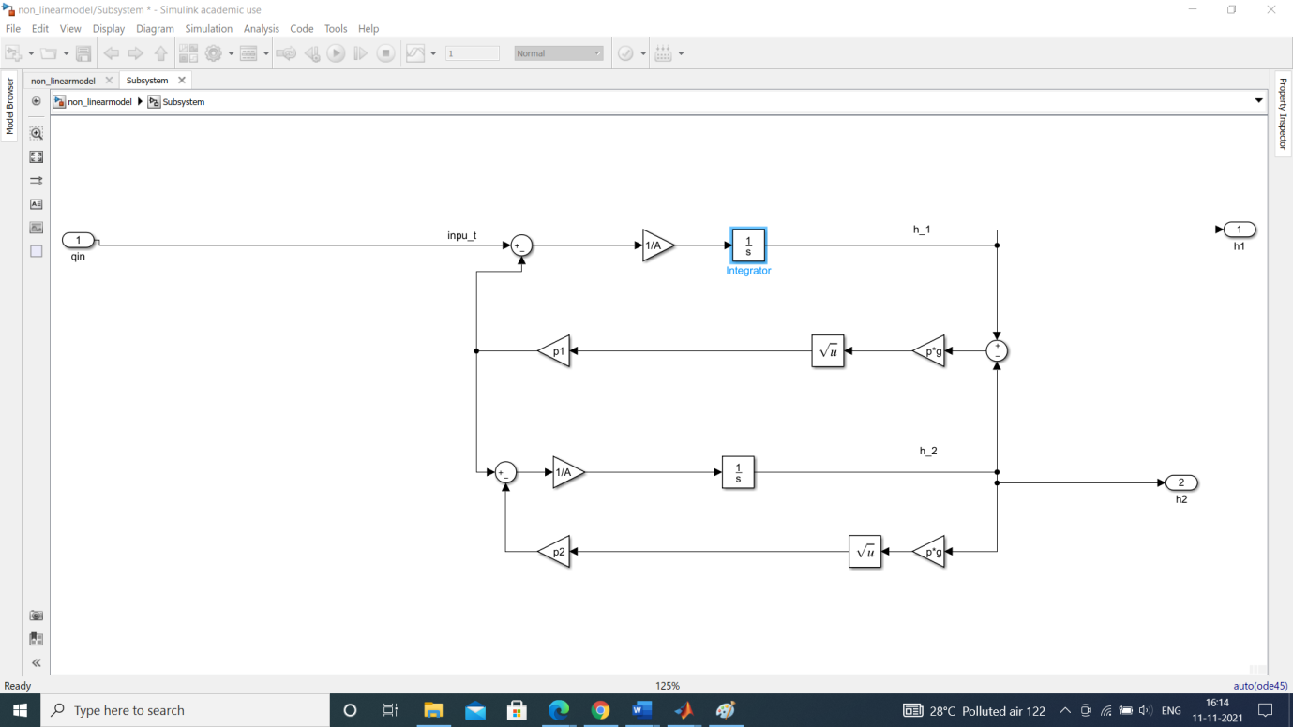

**Figure 7**: Subsystem

**2. MATLAB Code:**

clear all;clc

p1 = 1.262*10e-4;

p2 = 1.262*10e-4;

p=1;

A = 0.01;

g = 9.8066;

h2=0;

h1 = 2*h2;

u = 0.2*p2*sqrt(h2*g);

A_1 = [-0.0625 0.0625;0.0625 0.1248];

B = [100;0];

k1 = 1.09;k2 = 87.12;

sim('non_linearmodel');

t = ans.simout.time();

y1 = ans.simout.data(:,1);

y2 = ans.simout.data(:,2);

subplot(211);plot(t,y2,'b','Linewidth',1);

subplot(212);plot(t,y1,'r','Linewidth',1);

**3. Plots:**

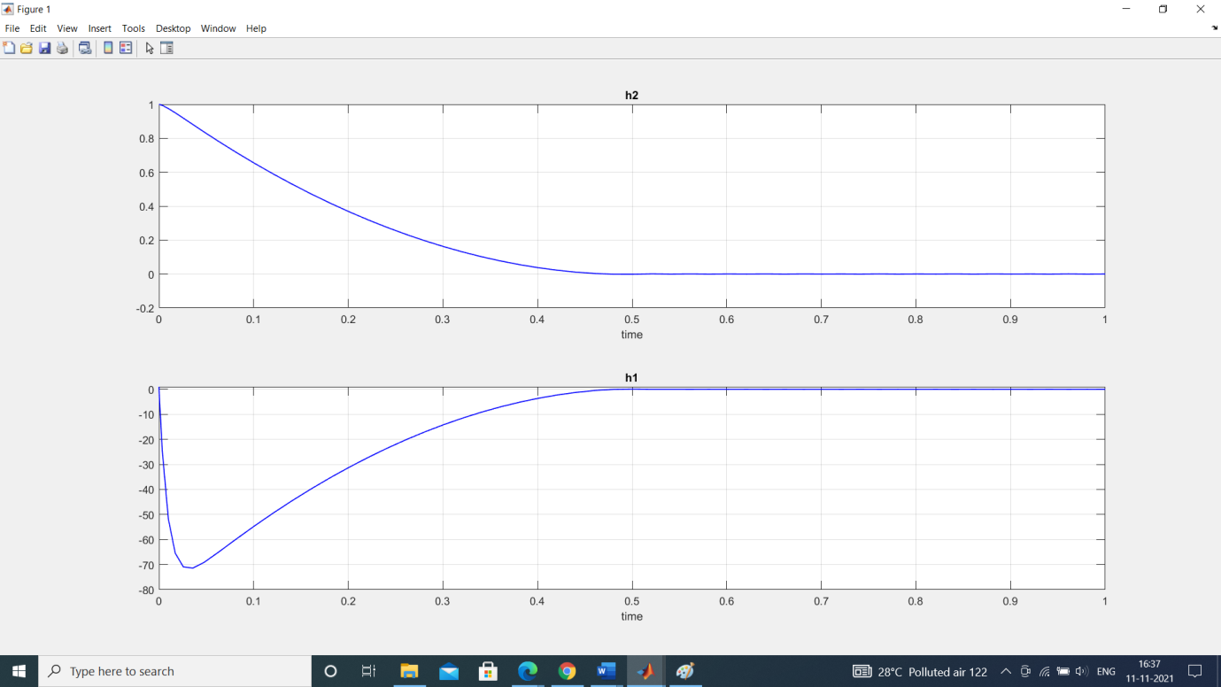

**Figure 8:** Response curve of closed-loop control system with initial condition [1 1].

**C. Performance comparison:**

The performance of the designed State Feedback controller on the linear and the non-linear system is compared with each other.

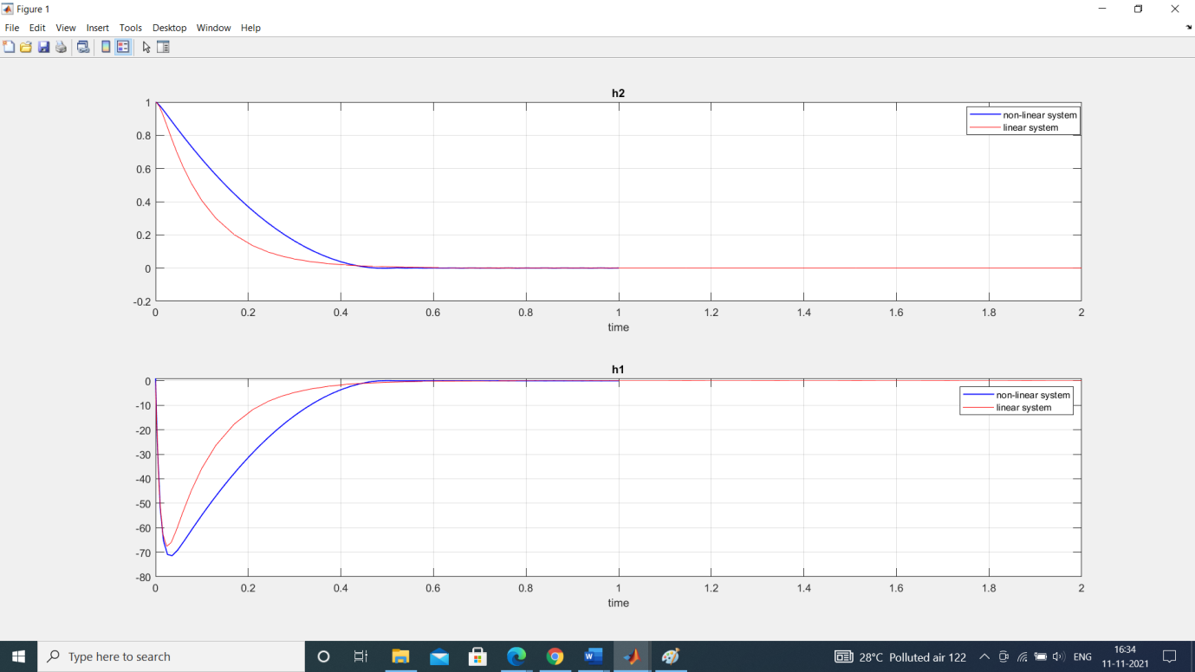

**Figure 9:** Response curve of linear and nonlinear system with initial condition [1 1].

**OBSERVER BASED CONTROLLER DESIGN**

**Case 1:**

**Given data:**

Desired closed loop pole location J = [-10, -100]

Observer Pole Locations L = [-1+j*2, -1-j*2]

**Step 1:** Check the observability condition of the system. The observability matrix is

O = [CT ATCT]

=

We find that O ,rank of observability matrix O=2.Hence the system is completely state observable.

**Step 2:** Assume that the state x is to be approximated by the state x′ of the dynamic model of observer

A x’ + B u + Ke (y – y’)

y’ = C x’

where x′ is the estimated state and Cx′ is the estimated output. The matrix Ke is called observer gain matrix.

[ A – Ke C] x’ + B u + Ke y

The system equation which is already known is given as

= A x+ B u

y = C x

Now the observer error equation is defined as:

x - [ A – Ke C] x- x’

where the above dynamics is error vector and the dynamic behaviour depends on eigen values of [A-KeC].

**Step 3:** By defining the desired state feedback gain matrix Ke=[ Ke1 Ke2]T

|SI – A + KeC|=0

s2+(0.5 + Ke2)s+(0.0308 + (Ke1+Ke2)/9)=0 …(a)

**Step 4:** Comparing (a) with the desired characteristics equation from desired poles(L) =

[-1+j*2, -1-j*2]

(s+1+j2)(s+1-j2)=0

s2+2s+5=0

Ke1 = 43.22

Ke2 = 1.5

**Step 5:** For calculating k = [k1 k2] for given closed loop poles(J)= [-10, -100]

|SI-A+Bk|=0

s2+(0.5+100k1)s+(38.89k1+0.16666+11.11k2)=0 …(b)

comparing (b) with s2+110s+1000 =0

k1= 1.095

k2=86.15

k1 k2 can also be calculated in MATLAB using acker formula which is mentioned in below code.

**Step 6:**

1. **Simulink model:**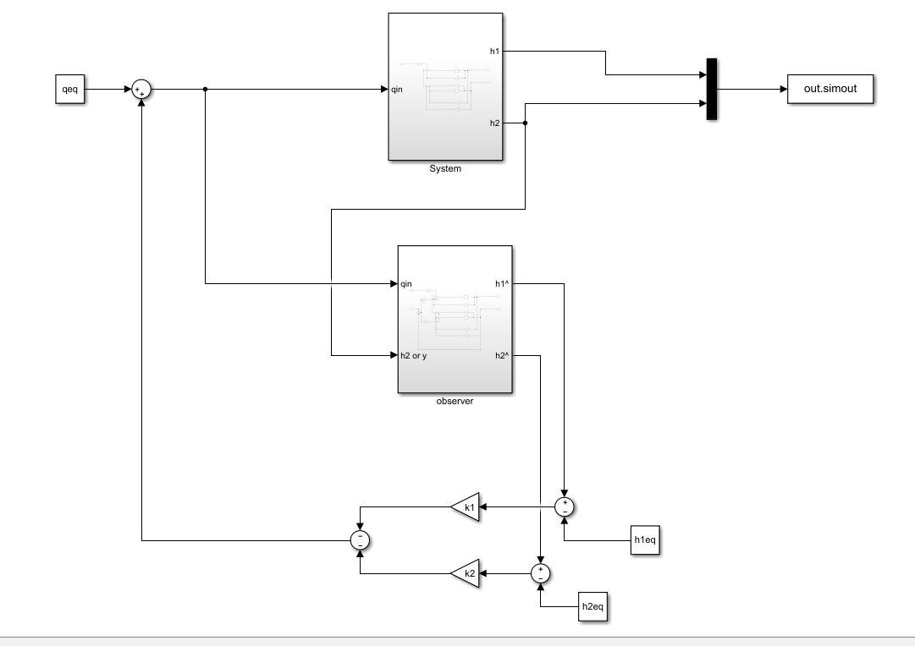

**Figure 10:** Observer based Simulink model.

**Subsystem (system block)**

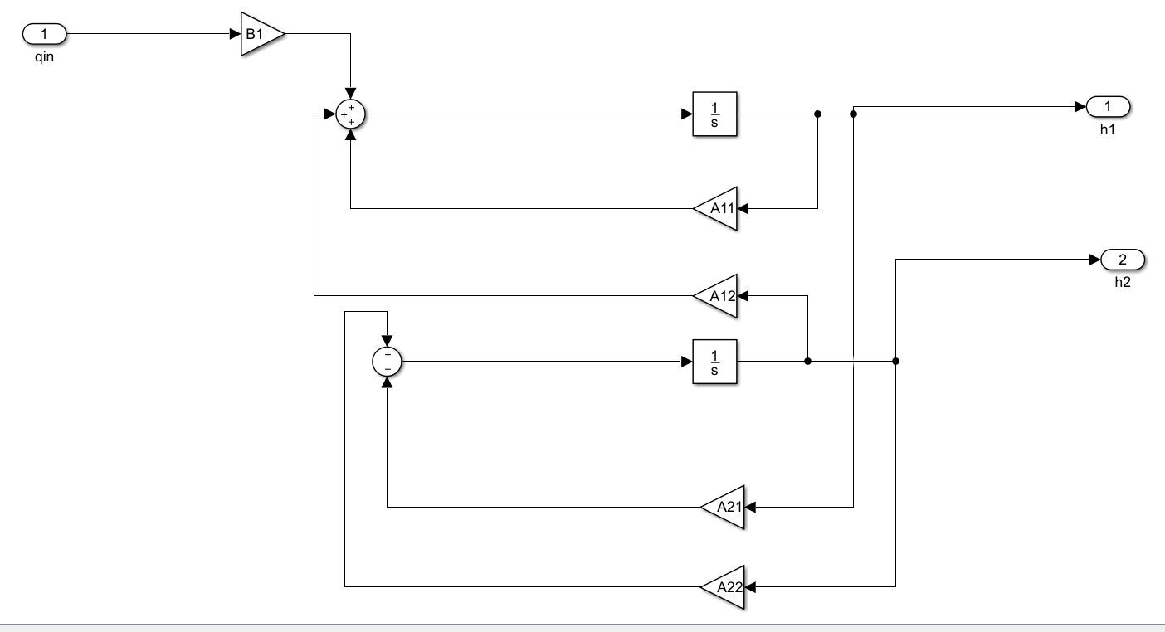

**Figure 11:**Subsystem(system)

**Subsystem (Observer)**

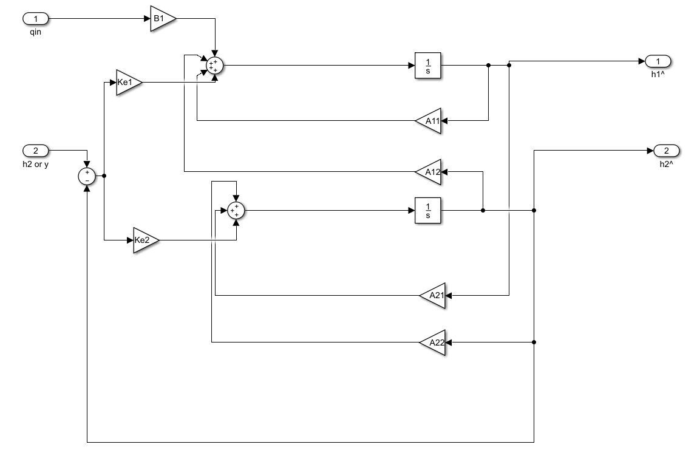

**Figure 12:** Subsystem (Observer)

1. **Matlab Code:**

clc

clear all

close all

tsim=2

qeq=0

h1eq=0

h2eq=0

A=[-1/9 1/9;1/9 -0.3889]

B=[100;0]

C=[0 1]

A11=A(1,1)

A12=A(1,2)

A21=A(2,1)

A22=A(2,2)

B1=B(1)

h1_init=0

h2_init=1

Ac=[A zeros(2,1);-C 0]

Bc=[B;0]

poles=[-10,-100]

k=acker(A,B,poles)

%case:1

k1=1.095

k2=86.15

Ke1=43.22

Ke2=1.5

sim("observerbaseddesign");

t=ans.tout

x1=ans.system.data(:,1)

x2=ans.system.data(:,2)

z1=ans.observer.data(:,1)

z2=ans.observer.data(:,2)

subplot(211)

plot(t,x1,"linewidth",2);

hold on;

plot(t,z1,"linewidth",1.5);

legend("actual","estimated")

xlabel("time")

ylabel("x1")

title("Height of tank1(h1)")

hold on;

subplot(212)

plot(t,x2,"linewidth",2);

hold on;

plot(t,z2,"linewidth",1.5);

title("Height of tank1(h2)")

legend("actual","estimated")

xlabel("time")

ylabel("x2")

hold off;

1. **Simulation Results(graph):**

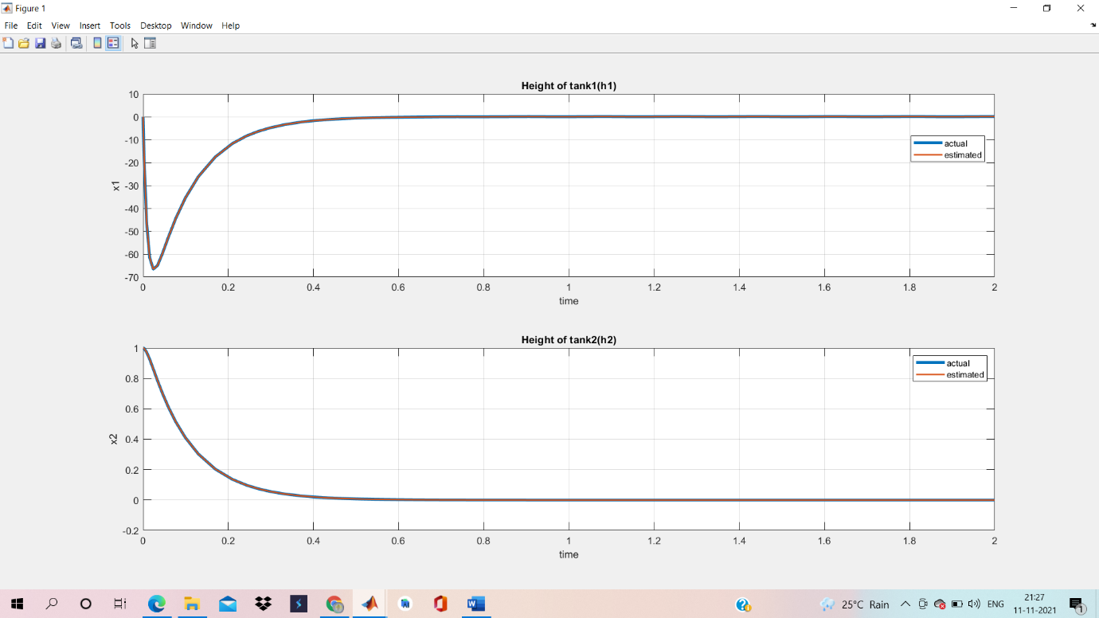

**Figure 13**: Response curve of actual output and estimated output of system with full order observer with initial condition [0 1].

**Case 2:**

**Given:**

Desired closed loop pole location of J=[-1+2j,-1-2j];

Observer pole location, L =[-10,-100];

**Step 1**: Desired state feedback matrix Ke = [Ke_1 Ke_2]T

| sI – A- KeC | = 0

s2 + (0.5+ Ke2)s +(0.0308+ .11(Ke1+Ke2)) =0……(a)

**Step 2**: Comparing above equation with desired characteristic equation with poles

L= [ -10, -100]

(s+10)(s+100) = 0

s2+110s+1000=0

Ke1=8981.12

Ke2=109.51

**Step3**: For calculating k= [k1 k2] for given closed loop poles J= [-1+2j, -1-2j]

|sI- A+ Bk| = 0

s2+(0.5 + 100k1)s +(38.89k1 + 0.1666 +11.11k2)=0…….(b)

Comparing equation (b) with s2+2s+5=0

k1=0.0151

k2=0.3997

**Step 4:**

1. **Matlab code**:

clc;

close all;

clear all;

a_11=-.11;

a_12=.11;

a_21=.11;

a_22=-.38;

b_11= 100;

b_21= 0;

A=[a_11 a_12; a_21 a_22];

B=[b_11; b_21];

C=[0 1];

P= ctrb(A,B);

M= obsv(A,C);

%case_2

poles=[-1+2j, -1-2j];

k= acker(A,B,poles);

k_1= k(1,1);

k_2= k(1,2);

k_e_1=8981.12;

k_e_2=109.51;

sim('linearmpcontrollerobserver.slx');

t=simout.time;

m = simout.data;

x__1=m(:,1);

x__2=m(:,2);

x__1hat=m(:,3);

x__2hat=m(:,4);

subplot(2,1,1)

plot(t,x__1,'linewidth',1.5);

hold on;grid on;

plot(t,x__1hat);

hold on;grid on;

xlabel('time');

ylabel('x_1');

title('height of tank 1');

subplot(2,1,2)

plot(t,x__2,'linewidth',1.5);

hold on; grid on;

plot(t,x__2hat);

hold on; grid on;

xlabel('time');

ylabel('x_2');

title('height of tank 2');

1. **Simulation Results:**

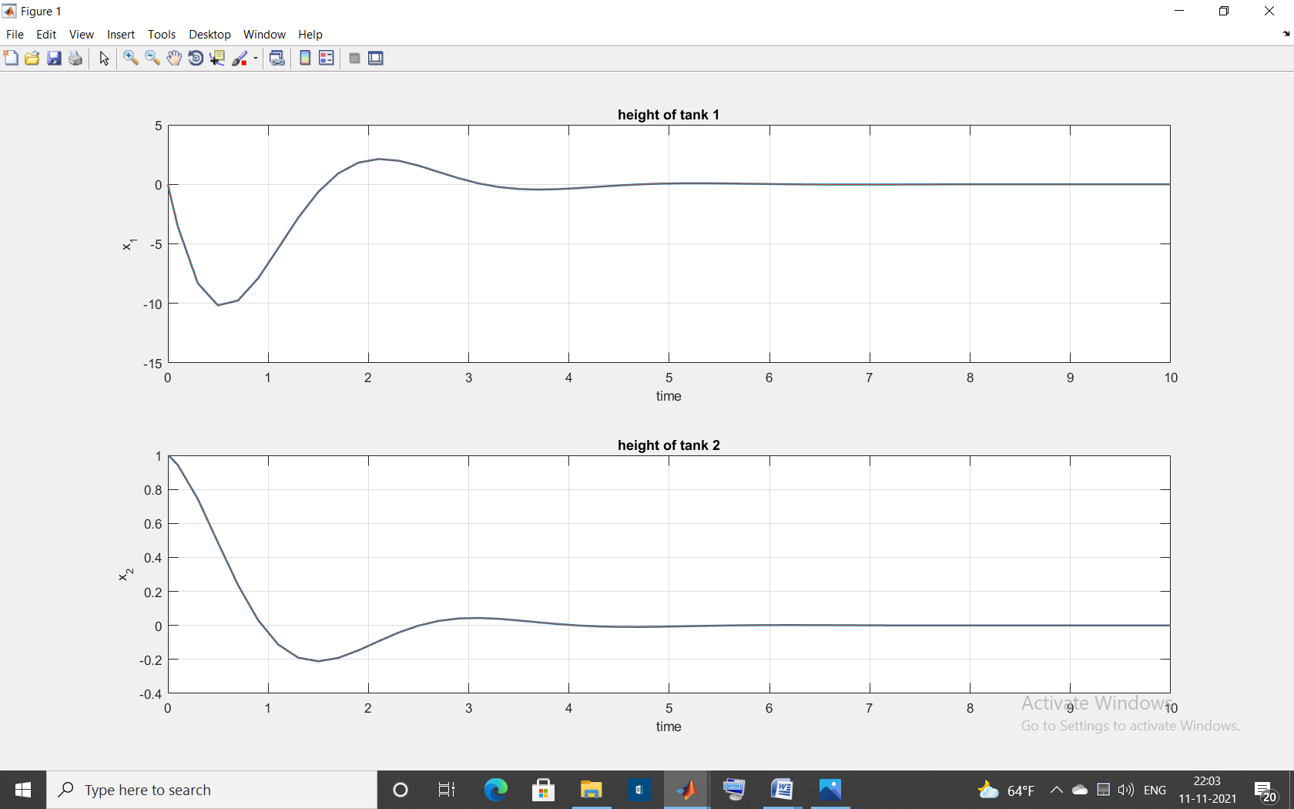

**Figure 14:** Response curve of actual output and estimated output of system with full order observer with initial condition [0 1] for case 2.

**Performance comparison:**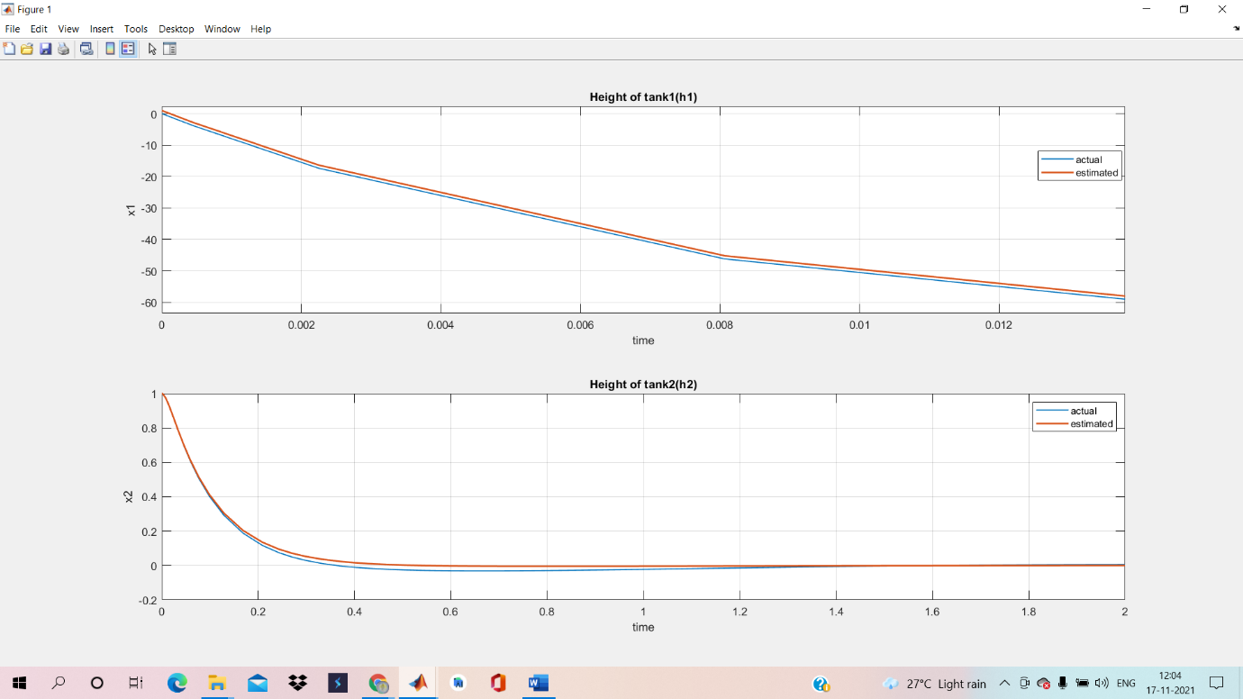

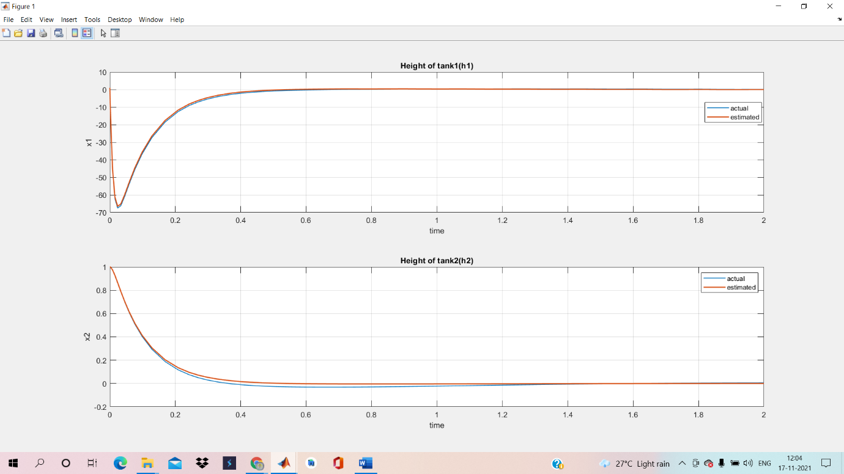

**Figure 15 :** Response curve of actual output and estimated output of system with full order observer with initial condition [1 1] and system with initial condition [ 0 1].

**LQR based controller**

**Step 1:**

Controllability Matrix = Mc = |B AB| = (2700 - 0) = 2700 ≠ 0

Hence Mc is a full rank matrix with rank = 2. So, the given system is controllable.

Check the observability condition of the system. The observability matrix is

O = [CT ATCT]

=

We find that O ,rank of observability matrix O=2.Hence the system is completely state observable.

System is both controllable and observable

**Step 2:**

Here in this case, number of uncontrollable states is 0 indicating that all the states are controllable. Therefore, the design of LQR controller is possible. The performance of LQR control is measured by performance index,

J=TQx+uTRu) dt

Q and R are chosen according to the requirement from the reference

Q=CTC=;

R=1;

**Step 3:**

The law of LQR controller is “u=-kx” that reduce the state fluctuation. This gain is called LQ-optimal gain. Control action is based on the state of process. The optimal state feedback gain is obtained by solving ARE (Algebraic Riccati Equation).

Algebraic Riccati Equation is

ATP+PA+Q - PBR-1BTP = 0

Solution P is needed to compute the optimal feedback gain K

P=

Kopt=R-1BTP

Kopt = [0.0423,0.8490]

**Step 4:**

J=(x0)TP(x0) (x0 = [0 1]T)

=0.3613.

**Step 5:**

1. **MATLAB code:**

clc

clear all

close all

qeq=0

h1eq=0

h2eq=0

A=[-1/9 1/9;1/9 -0.3889]

B=[100;0]

C=[0 1]

Q=C'*C

P= ctrb(A,B);

M= obsv(A,C);

R=1

[k,p,e]=lqr(A,B,Q,R,0)

k1=k(1)

k2=k(2)

A11=A(1,1)

A12=A(1,2)

A21=A(2,1)

A22=A(2,2)

B1=B(1)

sim("statefeedback",5);

t=ans.tout

x1=ans.simout.data(:,1)

x2=ans.simout.data(:,2)

subplot(211)

plot(t,x1);

xlabel("time")

ylabel("x1")

title("Height of tank1(h1)")

hold on;

subplot(212)

plot(t,x2);

title("Height of tank2(h2)")

xlabel("time")

ylabel("x2")

hold on;

**Simulation Result:**

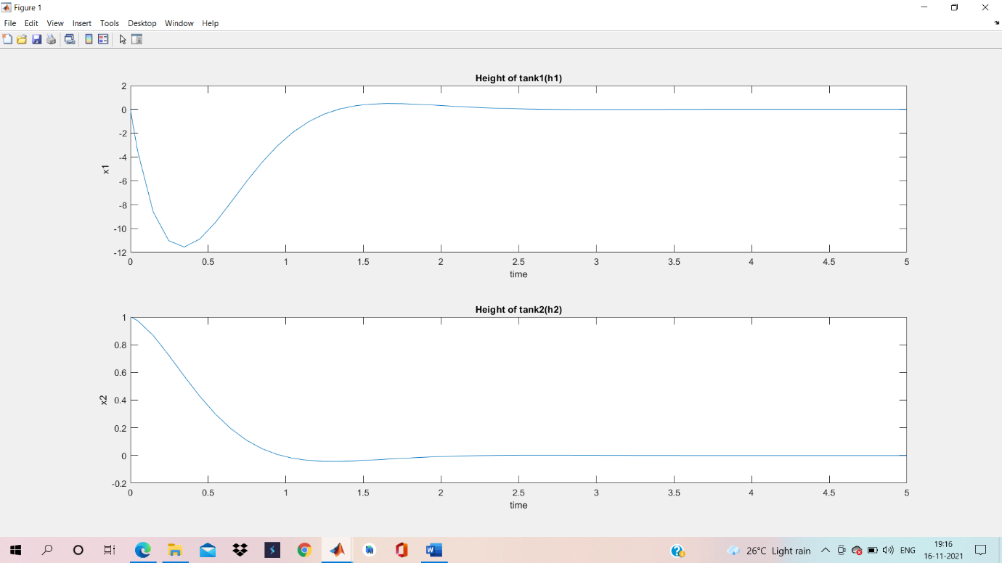

**Figure 16**: Response curve of system with lqr based controller with Q= [0 0;0 1], R=1.

**Comparison graphs for different values of Q and R:**

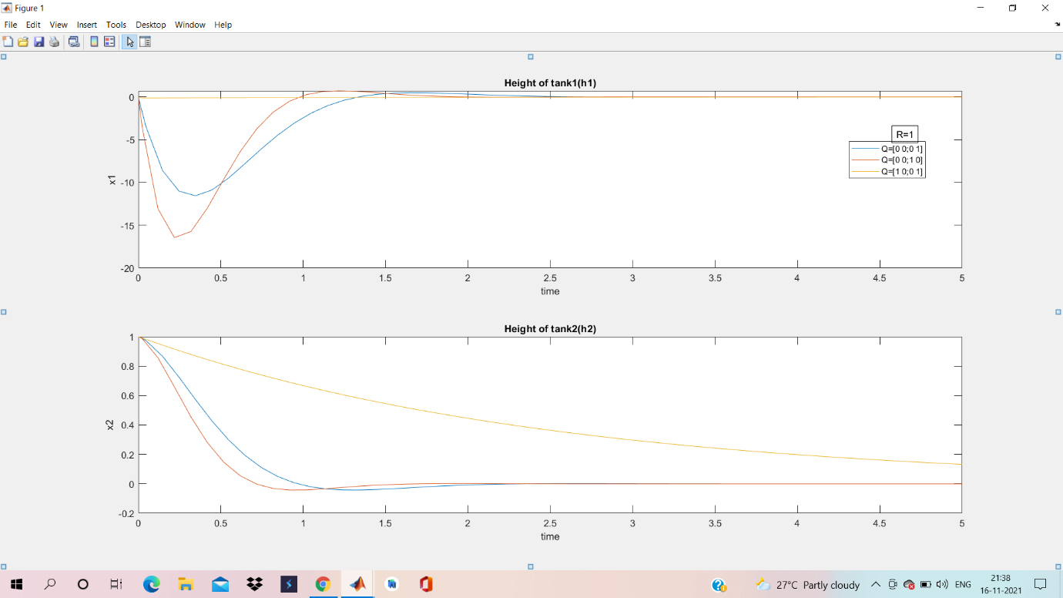

**Figure 17**: Response curves of system with lqr based controller with different values of Q and R=1.

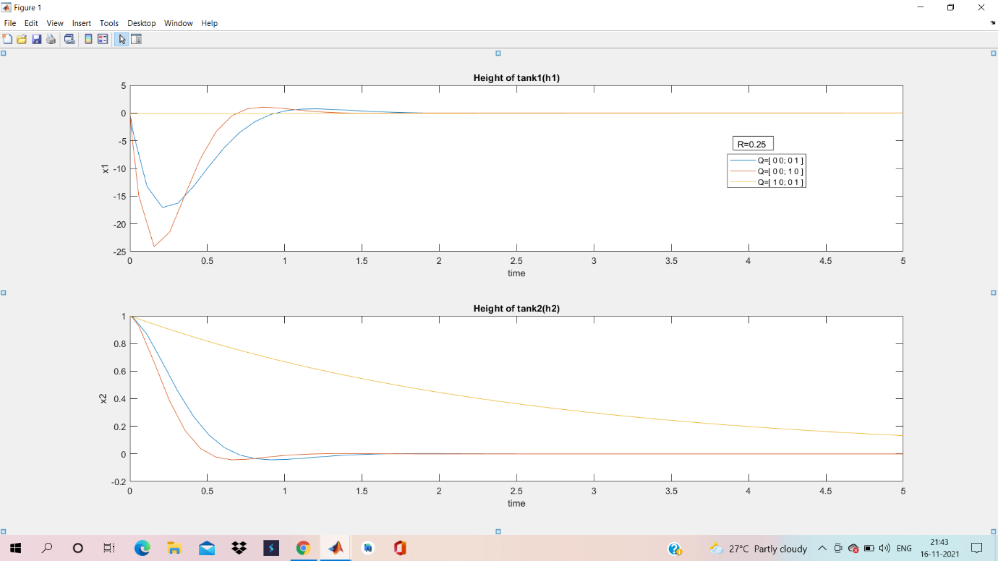

**Figure 18**: Response curves of system with lqr based controller with different values of Q and R=0.25.

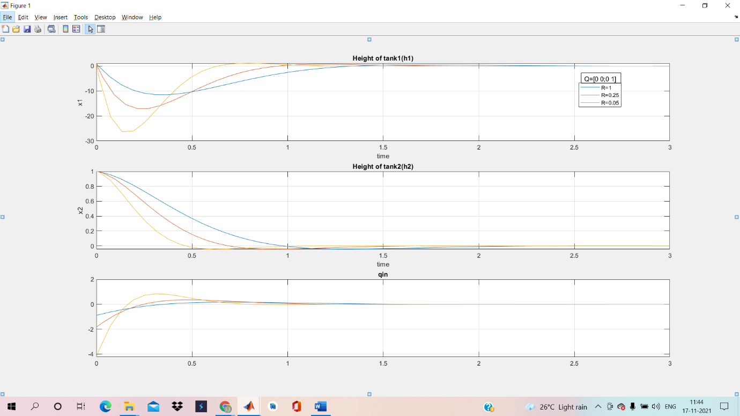

**Figure 19**: Response curves of system with lqr based controller with different values of R and Q= [0 0;0 1].

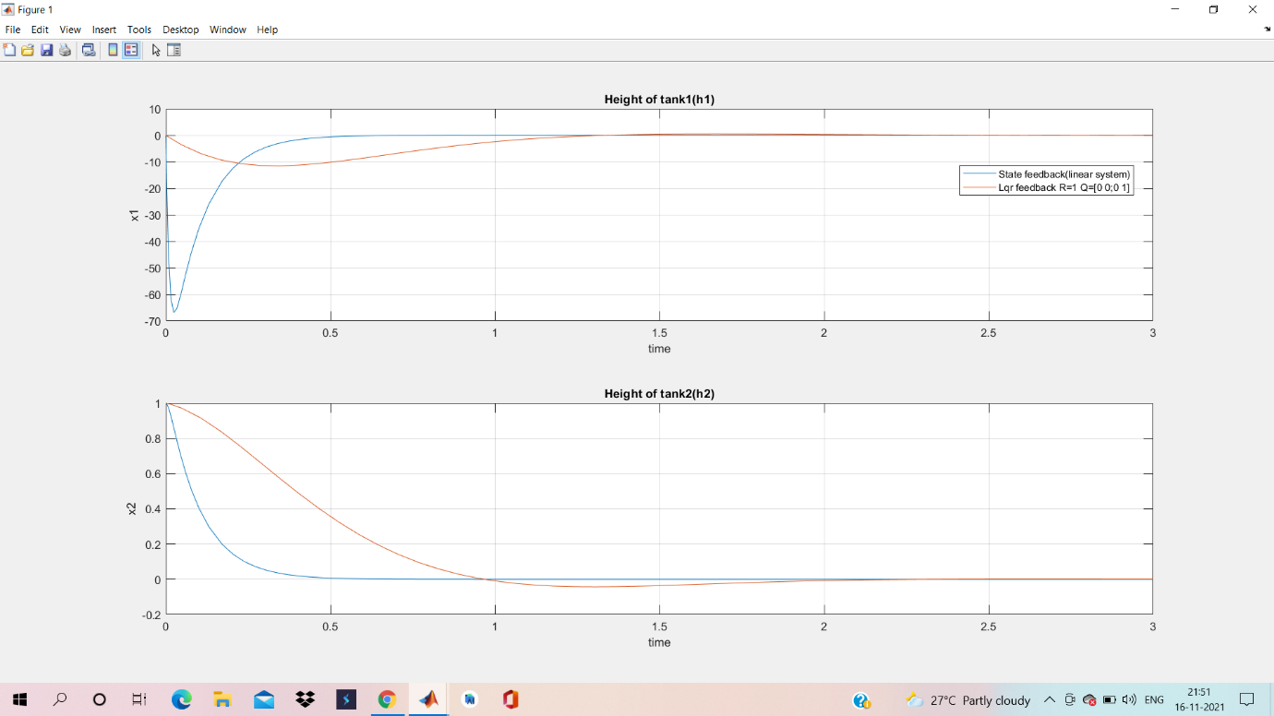

**Figure 20:** Comparison of response curves of controller with optimized k values (lqr based controller) with state feedback controller.

SUMMARY AND CONCLUSIONS:

1. Settling time of linear open loop system is 70 sec.
2. Settling time of non-linear open loop system is 20 sec.
3. Settling time of linear closed loop system with state feedback control is 0.7 sec.
4. Settling time of nonlinear closed loop system with state feedback control is 0.5 sec.

Both linear and nonlinear are tracking the desired set point but the linear one has less undershoot compared to nonlinear. With respect to linear system, Nonlinear has 7.46% more undershoot. Non-linear system settles 0.2 sec faster.

In observer-based model, the system turns out to be stable for both case 1 and case 2. The actual output and the estimated output coincides for same initial conditions. Both observer and the system start with different initial values for the states but finally observer tracks the actual states.

In LQR based design optimal cost turns out to be 0.3613.

If R is decreased, then the states converge faster and more input effort is required.  
If R is increased, then the states converge slower and less input effort is required.

LQR based design gives 83.58% less undershoot than state feedback design.

REFERENCES:

[1] K. Anbumani, R. Rani Hemamalini,” linear Quadratic Regulator for three Interacting Cylindrical Tank Control”, International Journal of Recent Technology and Engineering (IJRTE) ISSN: 2277-3878, Volume-8, Issue-1S4, June 2019.

[2] K. Ogata, Modern Control Engineering, 3rd edition, Prentice Hall, New Jersey, 1997.

[3] Roman A. Michurin1, Anatolii Schagin2,"Increase the Accuracy of the DC Motor Control System with a Linear-Quadratic Regulator",978-1-5386-4340-2/18,2018 IEEE.

[4] Amitava Biswas, Gargee Chakraborty,” Full Order Observer Controller Design for Two Interacting Tank System Based on State Space Approach” Department of Applied Physics, Calcutta University, 92, A. P.C Road, Kolkata-700009, INDIA, July 2017.